11th Grade English – American Literature

Semester One Project (formal)

During each semester, students will be responsible for one major project. For the first semester, students will complete the banned book project. The banned book project will be worth 100 points in total.

- Students will need to choose an age and reading level appropriate book that was once banned in either a high school or a public library.
- Upon selecting a book, students will need to turn in a parent signed and approved permission form that acknowledges which book the student will be researching, as well as the purpose of the assignment. Once a student turns in the parent approval form, I will give the student permission to begin their project. A book title may only be used by one student for each project; therefore, the faster you choose and get your title approved, the more likely you are to move forward with that book selection.
- Students will research, generate claims, and come to conclusions on whether or not they think the book should have been banned. Banned book projects must be presented before the last week of school instruction (December).
- Presentations must be a minimum of (5) minutes long, and should be in some sort of visual or auditory format (PowerPoint, Prezi, Website, Interactive Game, emaze, video, photographs, art—of all kinds, children’s book, interpretive dance, etc.). I encourage students to utilize formats that they may not be accustomed to.

Assignment Breakdown
Formal Assessment – 60% or more | Informal Assessments – 40% or less
Final exams and midterms  Standards-based tests and quizzes  Culminating projects  Essays (all types)  Lab reports  Presentations  Performances  Other demonstrations of proficiency | Small projects (formative)  Practice tests/quizzes  Checking for understanding activities  Homework/Out of Class Preparation  Drafts  Practice work  Classwork  Student involvement/participation  Class activities  Journals  Warm-ups

Hello Parents!

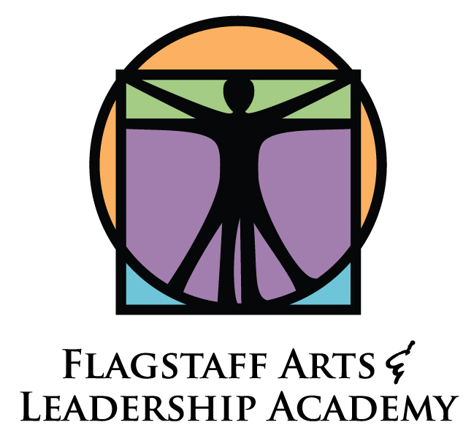
This semester, your student has been tasked with completing a Banned Book Project. The Banned Book Project assignment description and rubric are on your student’s webpage for your convenience.

Your student has chosen to read and research the book title _______________________ by the author __________________. This book must have been banned in either a High School library or a City/Council Public library for any length of time. Students must choose an age and content appropriate title to research for the class. After parent approval, the course instructor, Ms. Gilmore, will screen all titles before final approval is given.

Each student will turn in the Banned Book Project before the last day of instruction this semester. This assignment is a tool, designed to encourage students to create and customize time management and study skills that allow them to multi-task on a project that is not regulated in the classroom.

I cannot wait to see your student’s projects at the end of the year! If you have any questions or concerns, please contact me, Ms. Gilmore, at jgilmore@flagarts.com.

Thank you for your interest and participation in your student’s education.

Best Wishes,

Ms. Julia Gilmore
English Teacher
9th/10th/11th (American Literature)
Flagstaff Arts and Leadership Academy (FALA)

Parent Signature:

I agree __________________________________

I disagree _________________________________

